Making My First Webpages With HTML5
Create a New Folder MyDocuments/dig/website1
Create Three sub Folders :”Pages”, “Images” & “Library” MyDocuments/dig/website1/pages/, MyDocuments/dig/website1/images/, MyDocuments/dig/website1/library/
Start Notepad++ on your desktop. This is a text editor with a few extra features.
Copy the text below. These two tags are the absolute minimum for a web page to be valid HTML5 document.
The title tag is indented with two spaces. Indentation is used to visually block code to make it easier to read by humans. (The computer and browser do not care!)
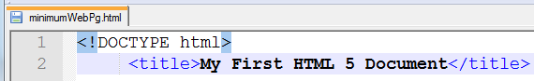

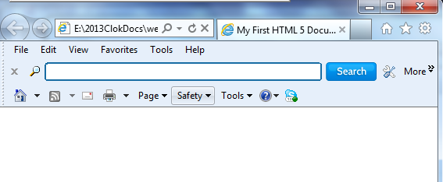
SaveAs: minimumWebPg.html in your pages folder
View this page in your browser (Internet Explorer)
So far the web page is blank, as there is no content.

(use camelCase for all file names in web creation. Camel case starts with a lowercase letter. There are no spaces between words. Each word except the first starts with a capital letter
In practice a few more tags are usually used when coding a web page. Add these to your HTML document and
SaveAs webPage1.html. In a browser this page is still blank, as there is no text in the body section.
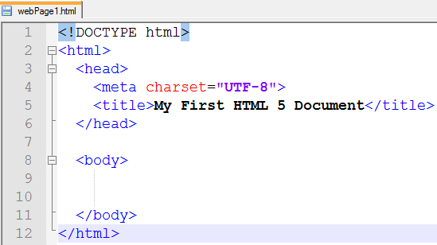
Save the updated file to keep these changes. This web page still has no content when you view it with Internet Explorer. The meta data in the head section ensures the characters you have entered are interpreted correctly. Meta tags generally provide information for the browser and the search engines.

Add text to your web page so it is the same as that in the box below. SaveAs webPage1b.html
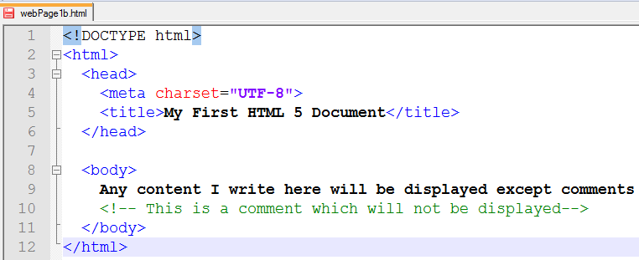
View this page in your browser (Internet Explorer)
Now you can see everything you typed between the body tags on your page,
The words between the <title> . . . </title> tags are displayed by the Browser in the blue title bar at the top of an Internet Explorer window, or in the Title Tab at the top of a Chrome page.
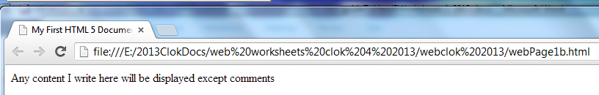

Making My Second Webpage With HTML5
File, Open webPage1b.html
SaveAs webPage2.html
Add text to your web page so it is the same as in the box below.
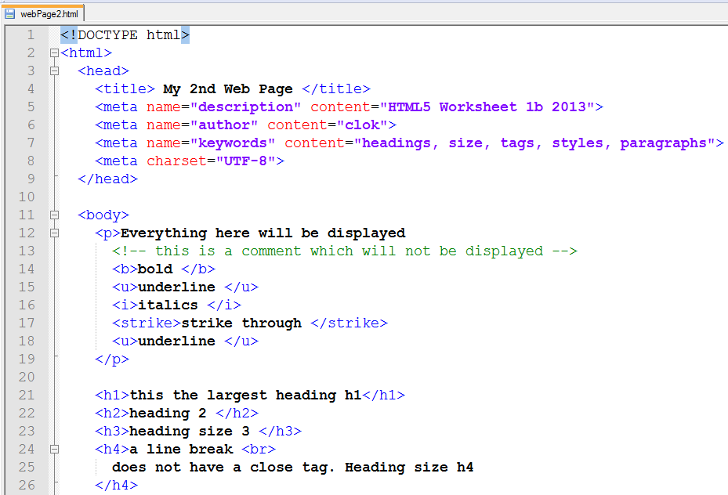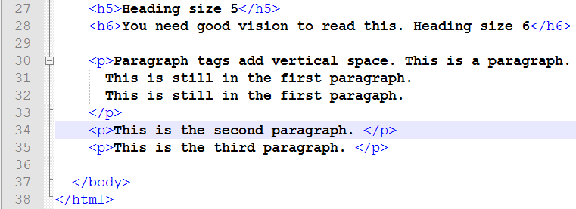

Save to update your page
View this page in your browser (Internet Explorer)
Study this code until you understand how each tag affects the content, layout and style of elements of the web page.

Making My Third Webpage With HTML5
File, Open webPage2.html with Notepad++
SaveAs webPage3.html
Update and add text to your web page so it is the same as that in the box below.
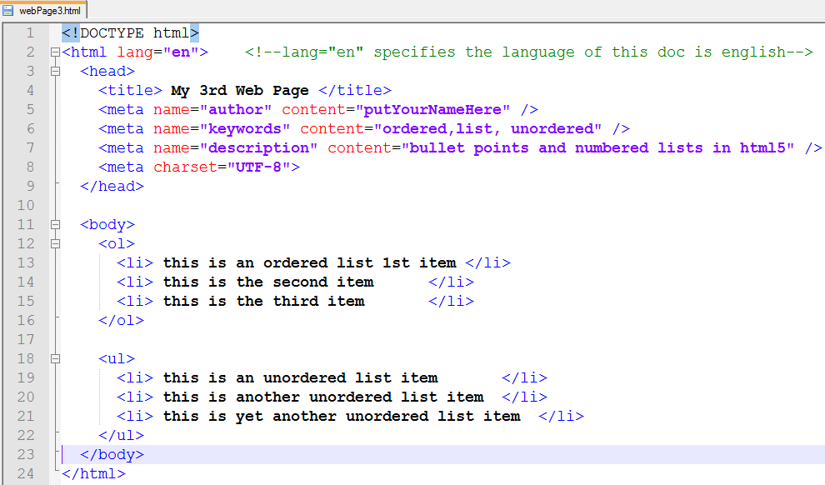
Save your page
View your page in a browser (Internet Explorer/ Chrome/Mozilla))
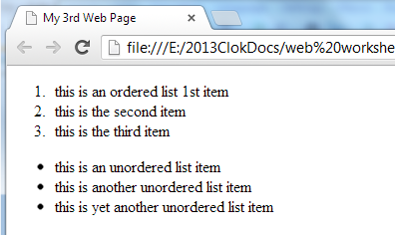

In an unordered list, bullets are non-alphanumeric characters or images.
In an ordered list, bullets are sequential alphanumeric characters.

Making My Forth Webpage With HTML5
This html shows you how to display images on your page. Before you start coding you will need to
Copy tiger.jpg and tiger-eyes.jpg from R:/Generalshare/digitalTech/html5Guide/images to your /images/ folder, then
File, Open webPage3.html with Notepad++
SaveAs webPage4.html
Update and add text to your web page so it is the same as that in the box below.
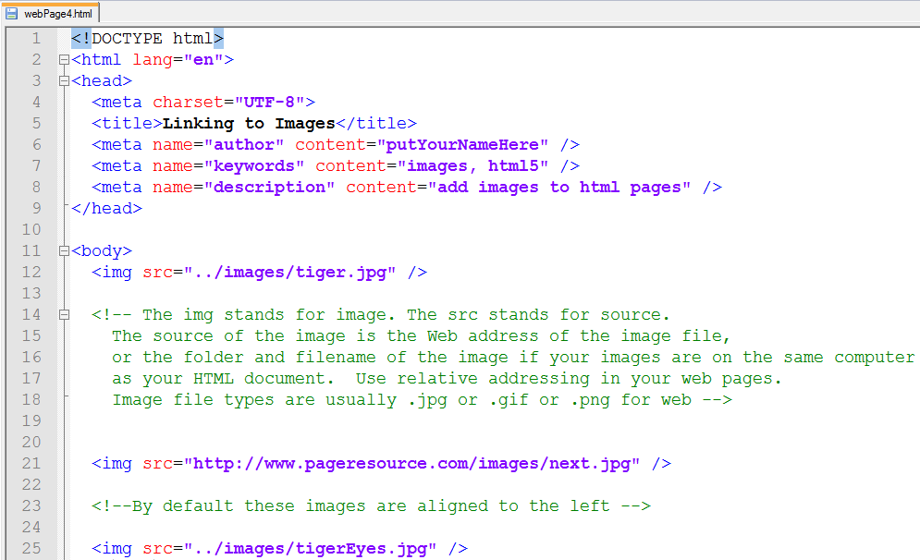
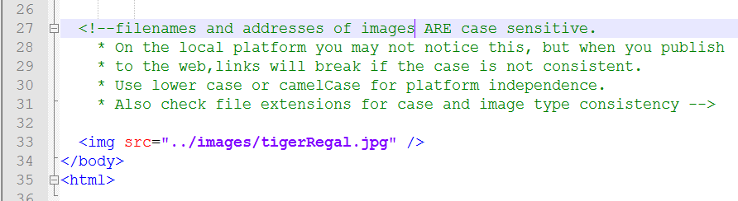

Save your page and then View it your browser (Internet Explorer)
