Worksheet 4: Making Web Sites With HTML5.

Task 10: Linking with buttons and other images.
- Read the document: “Buttons and Banners”, and make yourself some buttons in GIMP.
- Copy Website3, and rename the copy Website4
- Put your button images in the images folder
- Modify the new index page to use the buttons as links instead of the unordered list you used earlier.
- Set the border-style to none (border-style: none; ) for images, so a blue line doesn’t show around the links.

<!DOCTYPE html>
<html lang="en">
<head>
<meta charset="UTF-8">
<title>Task10 Using Images to link to other pages - Home Page</title>
<meta name="author" content="clok" />
<meta name="keywords" content="anchor, image, link, css3" />
<meta name="description" content="linking pages with images" />
<link rel="stylesheet" type="text/css" href="pages/style10.css" />
</head>
<body>
<div id = "container">
<header id="banner">
<img src= "images/banner/sepiaBanner.png" alt= "photographyBanner" width = "723px" height = "91px">
</header> <!--end of header division-->

<nav id= "leftNav">
<!-- The buttons below provide navigation, linking to the other pages of this site -->
<img src="images/buttons/homeButton.gif" width = "150px" height = "35px" alt= "Home Button"></br>
<a href="pages/secondPage.html"> <img src="images/buttons/portraitButton.gif" width = "150px" height = "35px" alt= "Portrait Link"></a>
<a href="pages/thirdPage.html"> <img src="images/buttons/landscapesButton.gif" width = "150px" height = "35px" alt= "Landscape Link"></a>
<a href="pages/forthPage.html"> <img src="images/buttons/architectButton.gif" width = "150px" height = "35px" alt= "Architecture Link"></a>
</nav> <!--end of leftNav division-->

<div id ="mainContent">
<p> Ipsum filler </p>
<img src = "images/tigerEyes.jpg" width="657px" height="230px" alt = "Tiger's Eyes">
</div> <!--end of mainContent division-->

<div id ="footer">
<p> this page was made in January 2013 by CLOK </p>
</div> <!--end of footer division-->
</div> <!-- end of container division>
</body>
</html>
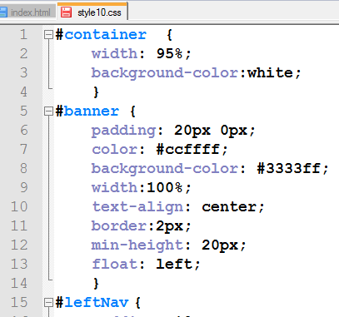

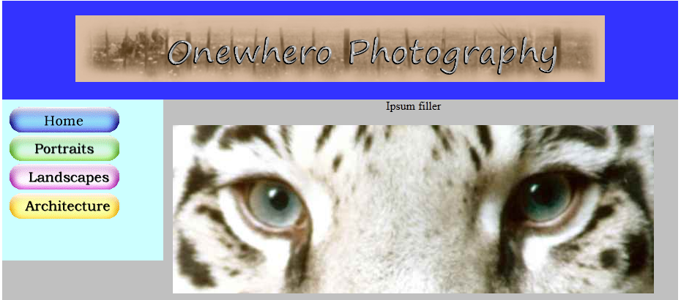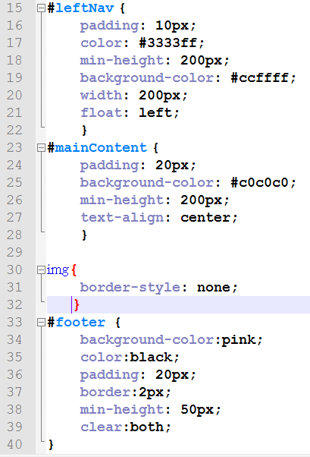

Task 11: Plan it, Structure it, Style it, Test it. Your Own Site.
- Read the document: “Wireframing a Website”.
- Really read it!
- In your visual diary create a wireframe for your own website. It should use your own content: buttons, banners, lists, images. You can base it on earlier tasks. Buttons and banners should be made in GIMP.
  - (later you could use HTML5 and CSS3 to make these, but at present jpg, png, and gif images have across browser compatibility, and we have a few more styling trick to learn.)
- In your planning include a site map for the whole site (3 pages)
- Make the folders. You know the ones!
- Create your index.html document in the root directory of your site. Style it with a linked CSS document in the pages folder. Copy your completed index file into the pages folder twice, renaming it as page2.html and page3.html. Modify the content of your subpages to match your planning.
- All you images should be in the images folder.
- Test all the links. Check the spelling and grammar. Get your site checked by your buddy. Validate it at the w3C validation site. Run Xneu link checker over the site. Fix any problems.
- If you want to, you can have your site published to oasdt.net (ask your tutor)

